**IR receiver**

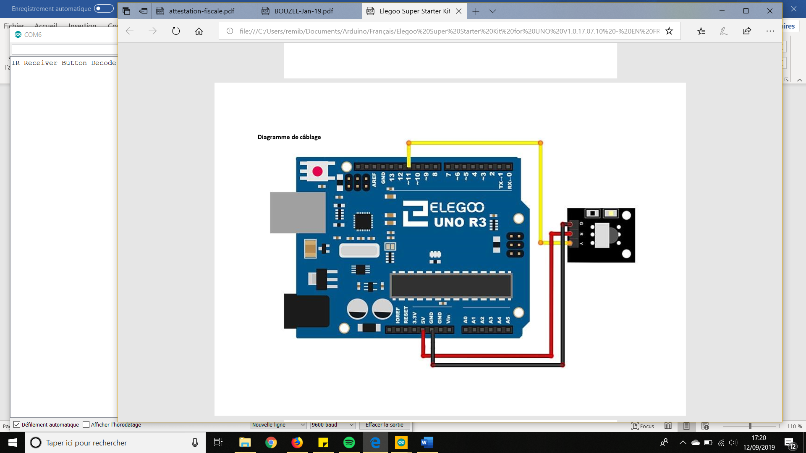

**Membrane keypad**

**Code**

* For the testing code (to slightly adapt from 4x4 to 4x3): <https://www.instructables.com/id/Connecting-a-4-x-4-Membrane-Keypad-to-an-Arduino/>

**Flexible membrane**

* Piece of code to modify:
  + // MEMBRANE KEYPAD FLEXIBLE
  + byte rowPins[ROWS] = {9, 8, 7, 6}; //connect to the row pinouts of the keypad
  + byte colPins[COLS] = {5, 4, 3}; //connect to the column pinouts of the keypad
* Picture:

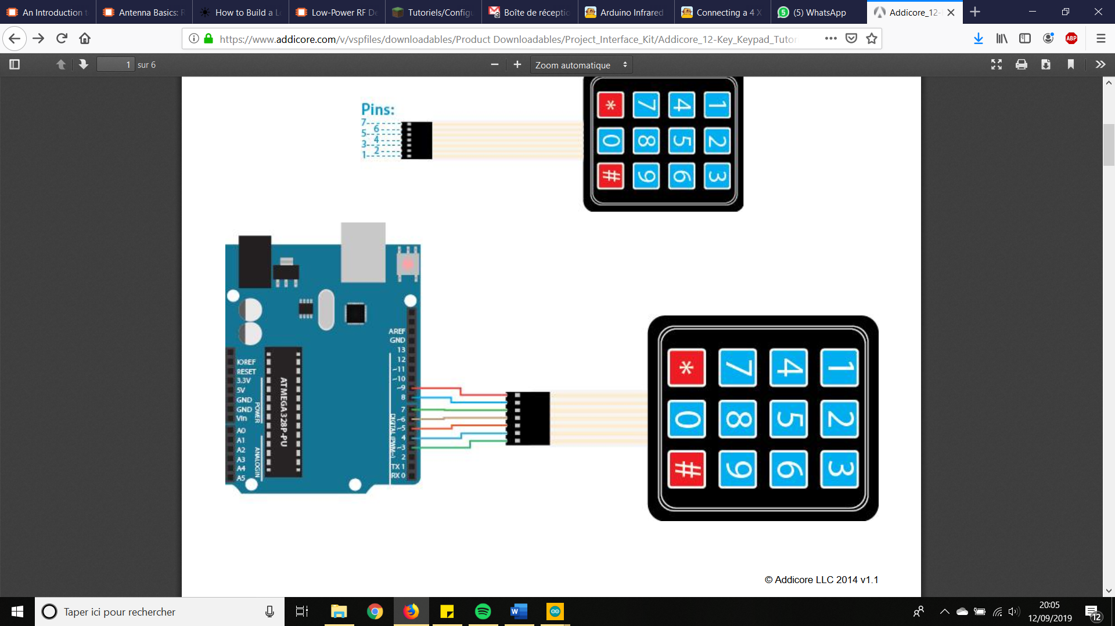

From <https://www.addicore.com/v/vspfiles/downloadables/Product%20Downloadables/Project_Interface_Kit/Addicore_12-Key_Keypad_Tutorial.pdf>

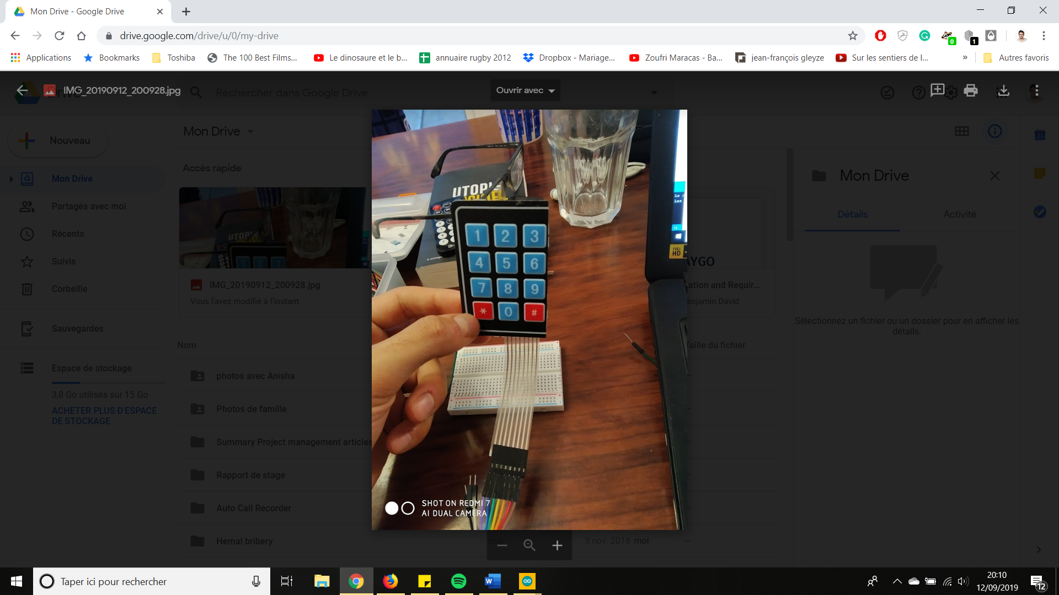 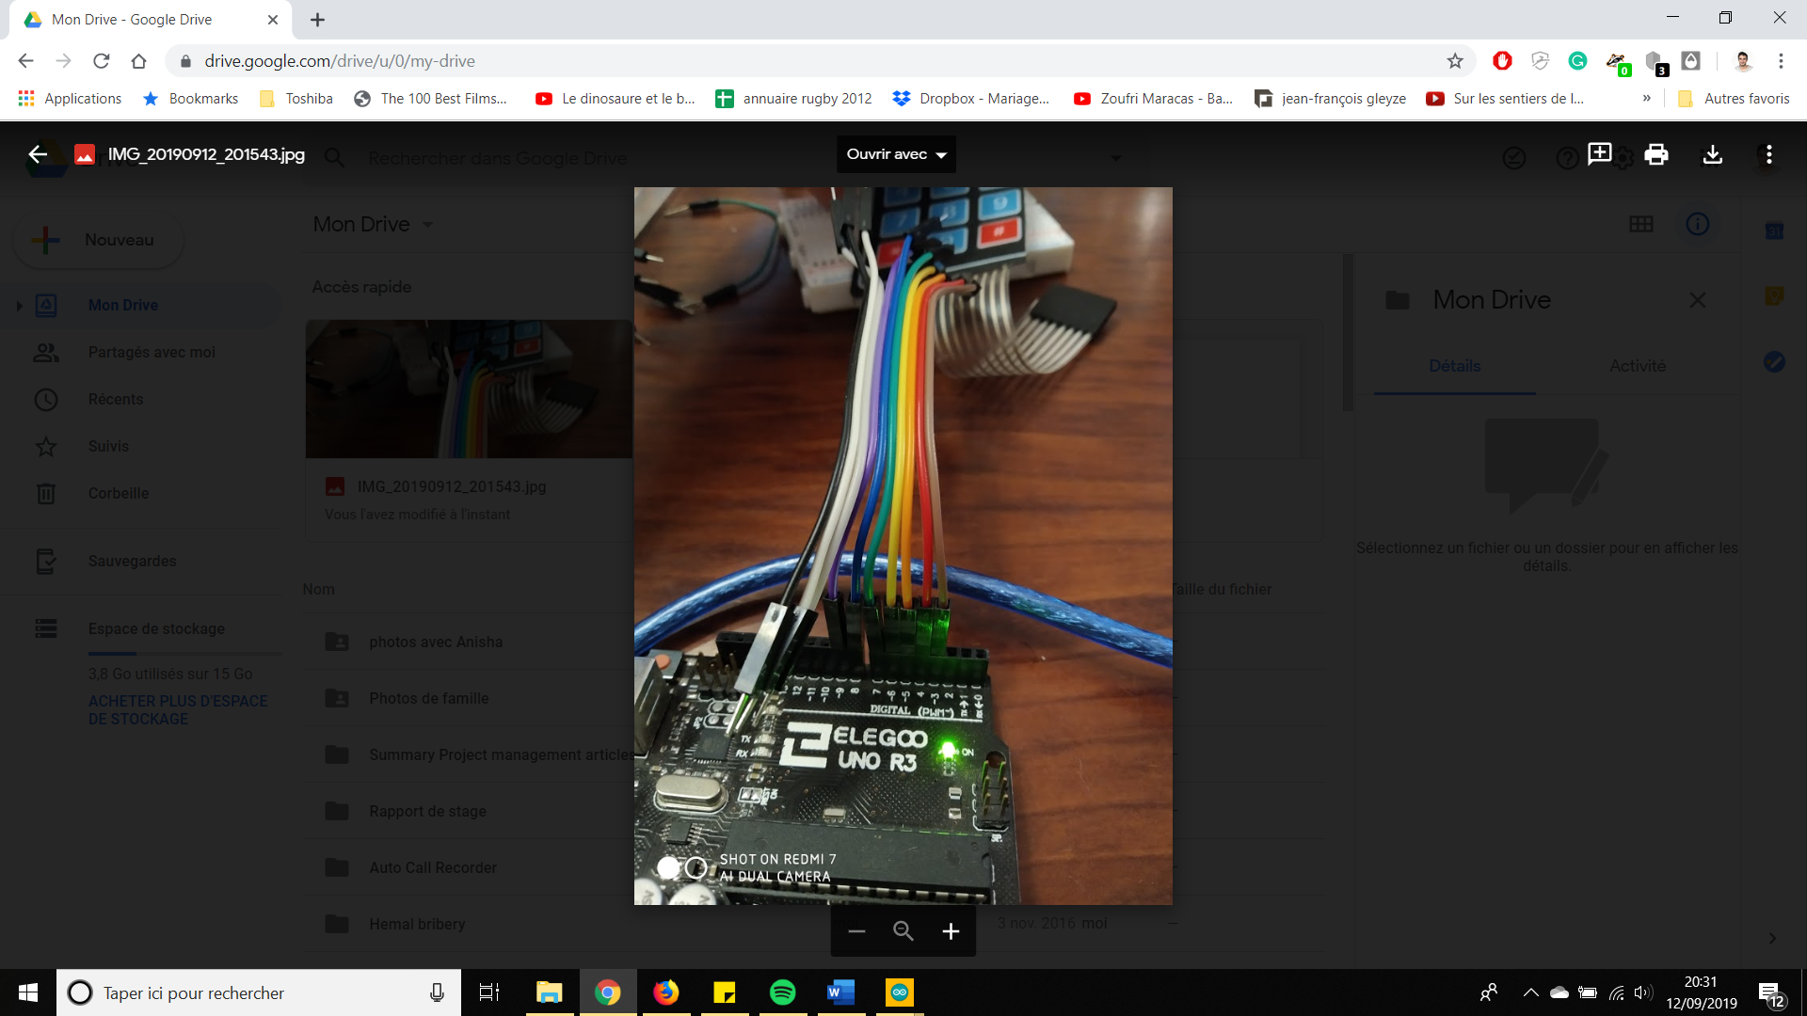

**None-flexible membrane**

* Resource for graph and code: <http://learning.grobotronics.com/2013/07/using-a-3x4-keypad/>
* Piece of code to modify:
  + // MEMBRANE KEYPAD HARD
  + byte rowPins[ROWS] = {5, 4, 3, 2}; //connect to the row pinouts of the keypad
  + byte colPins[COLS] = {8, 7, 6}; //connect to the column pinouts of the keypad
* Pictures:

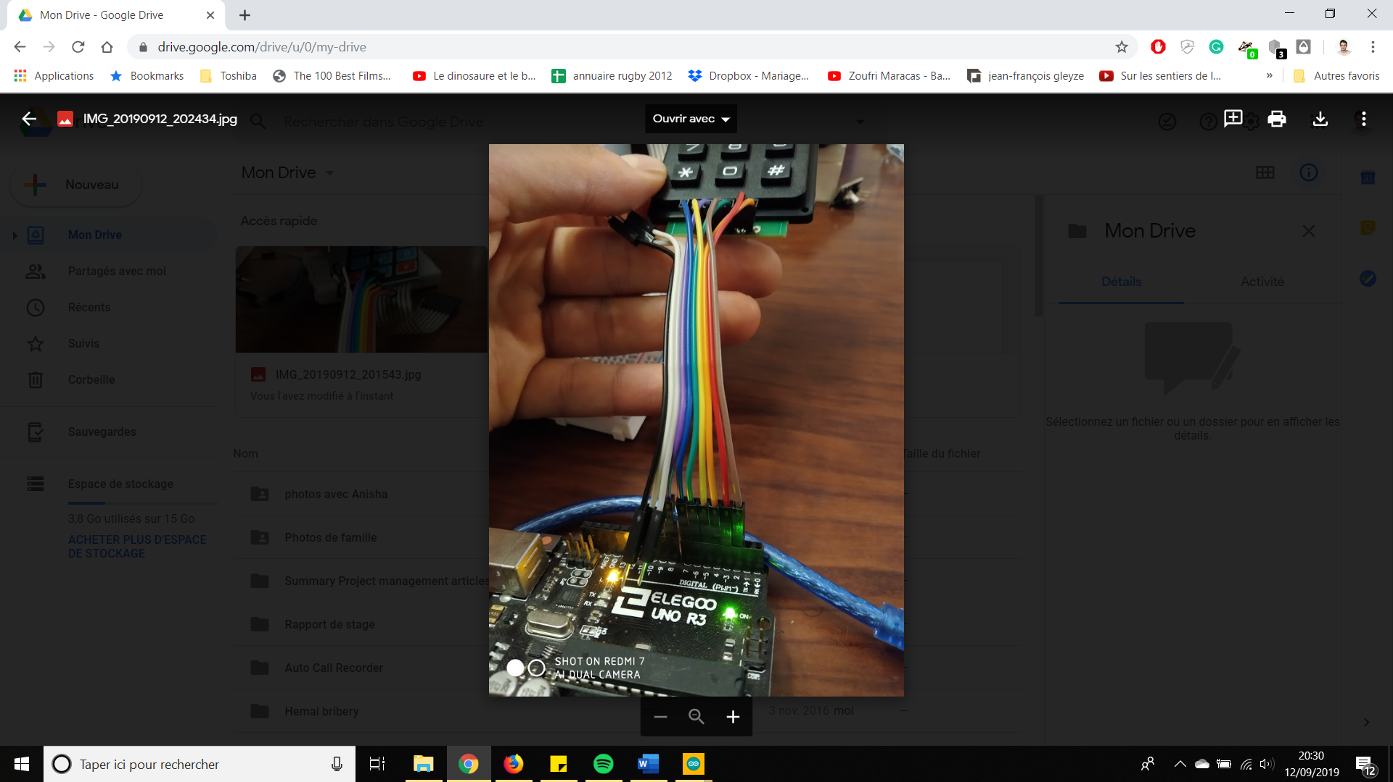 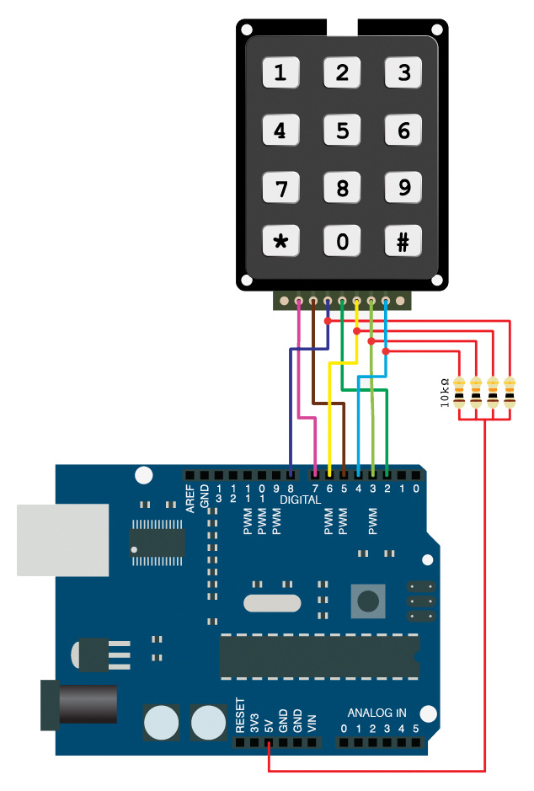

**RTC module**

* Model: Tiny RTC module DS1307
* Only for 5V
* Good resource in French: <https://www.carnetdumaker.net/articles/utiliser-un-module-horloge-temps-reel-ds1307-avec-une-carte-arduino-genuino/#le-module-ds1307>
* Connections :
  + VCC --> +5v
  + GND --> GND
  + SDA --> pin A4
  + SCL -->pin A5